NEW FALL 2018 FILM CLASS!!
"GREAT LEADING MEN—PART 2"
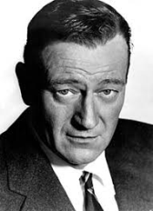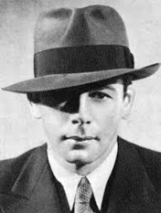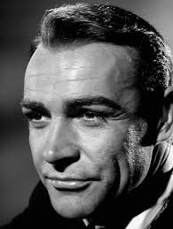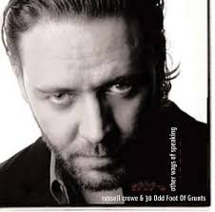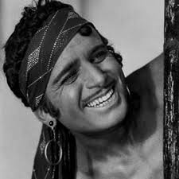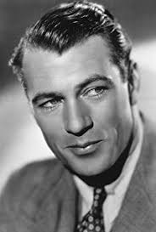
A screening and discussion 8 week series of some of the best actors in movie history!
-It could be Gary Cooper!
-It could be Russell Crowe!
-It could be Paul Muni!
Or, maybe John Wayne or Sean Connery!
...or all of those and more!!
(We never tell you beforehand what you will see!)
The Avon Film Classes, hosted by Avon Theater “Head Honcho” SKIP HUSTON are now in their 19th year!!
Come and join a whole city cross-section of film buffs, as we discover and discuss the magic of the movies!
CLASSES BEGIN THURSDAY, SEPT. 20th thru THURSDAY, NOVEMBER 8th
---AS USUAL, CLASS STARTS AT 6:30 PM
COST IS $80, PAYABLE BY CASH, CHECK or CREDIT CARD (Cash or Checks preferred)
PAYMENT SHOULD BE DIRECT TO THE AVON THEATER,
CHECKS SHOULD BE MADE PAYABLE TO: TMG LLC
+++++++++++++++++++++++++++++++++++++++++++++++++++++++++++++++++++++++++
(Bring this form with $80 payment to the Avon box-office before or on the first night of class)
NAME___________________________________ EMAIL ADDRESS____________________________
MAILING ADDRESS_______________________________________________________________
PHONE: _________________

Questions? Contact Skip Huston via email at Skip@TheAvon.com
-Or call 422-1776

